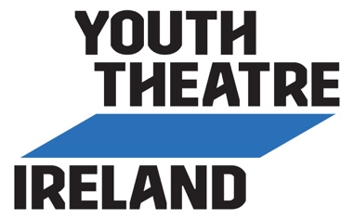
CTB YT COVID-19 Declaration Form (U18)
COVID-19 DECLARATION FORM
For Young People Aged Under 18

This Covid-19 Declaration Form is part of our Response Plan to help reduce the spread of Covid-19. Prior to returning to youth theatre activities, please read and answer the following questions on behalf of your son/daughter.
If the answer is Yes to any of the questions numbered 1 to 5, you are advised to seek medical advice for your son/daughter and complete any required period of self-isolation before they participate in youth theatre activities.
If their status changes after you submit this form, please inform the youth theatre at shirleymcsweeney@hotmail.com or call Shirley 087 1234954/ Maria 087 9141206.

Young Person:
Parent / Guardian:
Parent / Guardian’s Email:
Parent / Guardian’s Mobile:

 | YES  ✓ | NO  ✓
- Does your son/daughter have symptoms of cough, fever, high temperature, sore throat, runny nose, breathlessness or flu like symptoms now or in the past 14 days?
- Has your son/daughter been diagnosed with confirmed or suspected COVID-19 infection in the last 14 days?
- Is your son/daughter a close contact of a person who is a confirmed or suspected case of COVID-19 in the past 14 days (i.e., less than 2 metres for more than 15 minutes accumulative in 1 day)?
- Has your son/daughter been advised by a doctor to self-isolate at this time?
- Has your son/daughter been advised by a doctor to cocoon at this time?
If yes, please contact Youth Theatre Leaders to discuss alternative ways to stay in touch with youth theatre activities.
- Has your son/daughter been advised by a doctor that they are in an at-risk group?
If yes, please liaise with your doctor and Youth Theatre Leaders regarding their safe participation in the programme.

I confirm, to the best of my knowledge, that my son / daughter has no symptoms of COVID-19, is not self-isolating or awaiting results of a COVID-19 test.

Parent/ Guardian’s Signature: ___________________________________ Date: ________________

Please email to shirleymcsweeney@hotmail.com

Please note: CTB Youth Theatre is collecting this sensitive personal data for the purposes of maintaining safety at our activities due to the COVID-19 pandemic. The legal basis for collecting this data is based on vital public health interests and maintaining occupational health. The COVID-19 Declaration Form will be deleted immediately once it has been assessed by youth theatre leaders, has been recorded as being received and any necessary follow-up action has been taken.

